Lab plan No.6 Name: Muhammad Faizan Reg No.21-NTU-CS-1258

# Question No.1

## Input:

#include <iostream>

using namespace std;

void letter();

int main()

{

letter();

return 0;

}

void letter()

{

char c;

cout<<"Enter the character: ";

cin>>c;

if(c>='A'&&c<='Z')

{

cout<<"It is capital Letter";

}

else if(c>='a'&&c<='z')

{

cout<<"It is small Letter";

}

else

{

cout<<"It is not a Letter";

}

}

Output:  
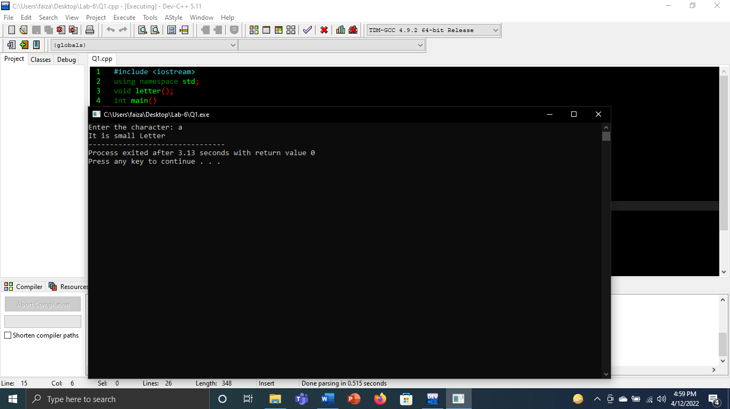

# Question No.2

## Input:

#include<iostream>

using namespace std;

float add(float n1,float n2,float n3,float n4,float n5)

{

float sum;

sum=0.0;

sum=n1+n2+n3+n4+n5;

cout<<"Sum is "<<sum<<endl;

return sum;}

float multi(float n1,float n2,float n3,float n4,float n5)

{

float product;

product=1.0;

product=n1*n2*n3*n4*n5;

cout<<"Multiply is = "<<product<<endl;

return product;

}

int main()

{

float a=1.1, b=2.3, c=3.3, d=4.4, e=1.2;

add(2.1,2.2,2.3,2.4,2.5);

add(a,b,c,d,e);

multi(2.1,3.2,4.3,5.4,6.5);

multi(a,b,c,d,e);

return 0;

}

## Output:

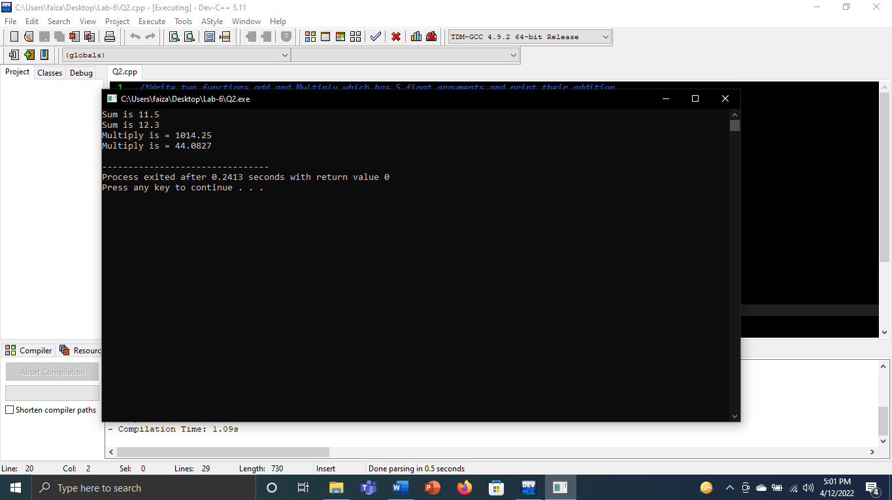

# Question No.3

## Input:

#include <iostream>

using namespace std;

void asterisks(int);

int main()

{

int num;

cout<<"Enter any variables ";

cin>>num;

asterisks(num);

cout<<endl;

asterisks(5);

return 0;

}

void asterisks(int num)

{

for(int i=1;i<=num;i++)

{

cout<<"*";

}

}

## Output:

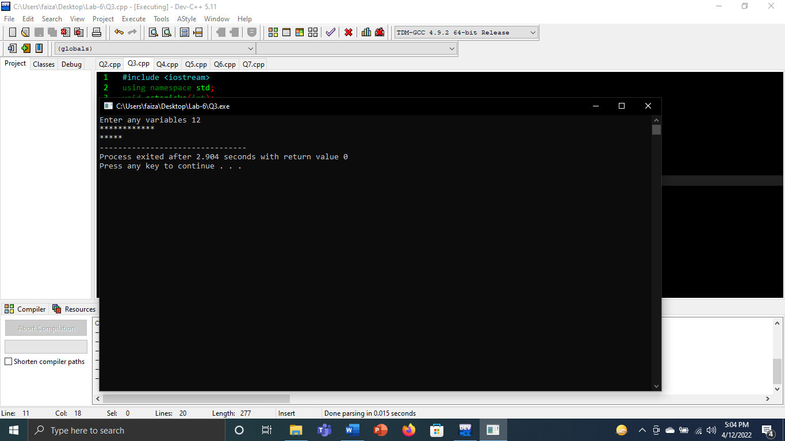

# Question No.4

## Input:

#include<iostream>

using namespace std;

int print(char l,int s)

{

int c1,c2,letter,size;

for(c1=1;c1<=6;c1++){

for(int c2=1;c2<=s;c2++){

if ((c1==1||c1==6)||(c2==1||c2==s))

cout<<l;

else

cout<<" ";

}

cout<<endl;

}

return letter;

return size;

}

int main()

{

int size;

char letter;

cout<<"Enter the character =";

cin>>letter;

cout<<"Enter the size =";

cin>>size;

print(letter,size);

print('L',15);

return 0;

}

## Output:

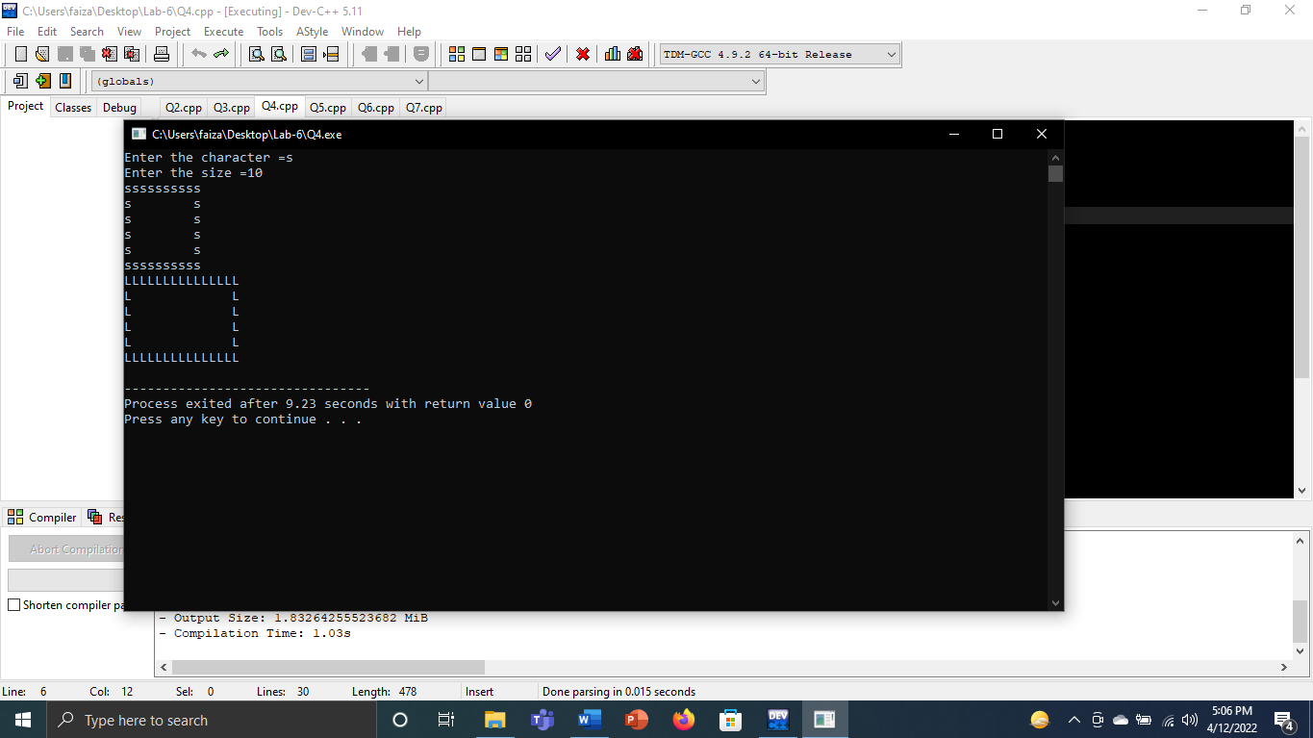

# Question No.5

## Input:

#include<iostream>

using namespace std;

float avg(float n1,float n2,float n3,float n4,float n5)

{

float ans=0;

ans=(n1+n2+n3+n4+n5)/5;

cout<<"Average is ="<<ans;

return ans;

}

int main(){

float num1,num2,num3,num4,num5;

cout<<"Enter the five numbers =";

cin>>num1>>num2>>num3>>num4>>num5;

avg(num1,num2,num3,num4,num5);

cout<<endl;

system("pause");

return 0;

}

## Output:

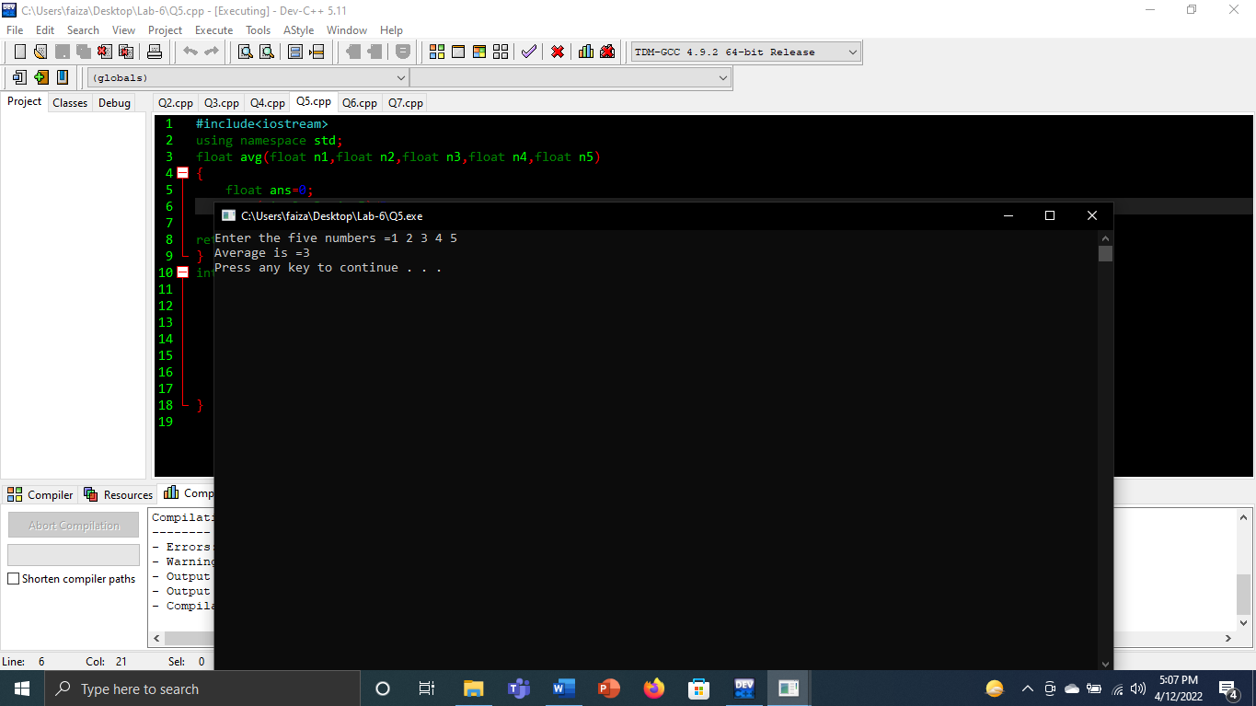

# Question No.6

## Input:

#include<iostream>

using namespace std;

void print(int x,int y)

{

(x>y)?cout<<x<<"x is largest":cout<<y<<"y is smaller";

}

int main(){

int x,y;

cout<<"Enter two num =";

cin>>x>>y;

print(x,y);

return 0;

}

## Output:

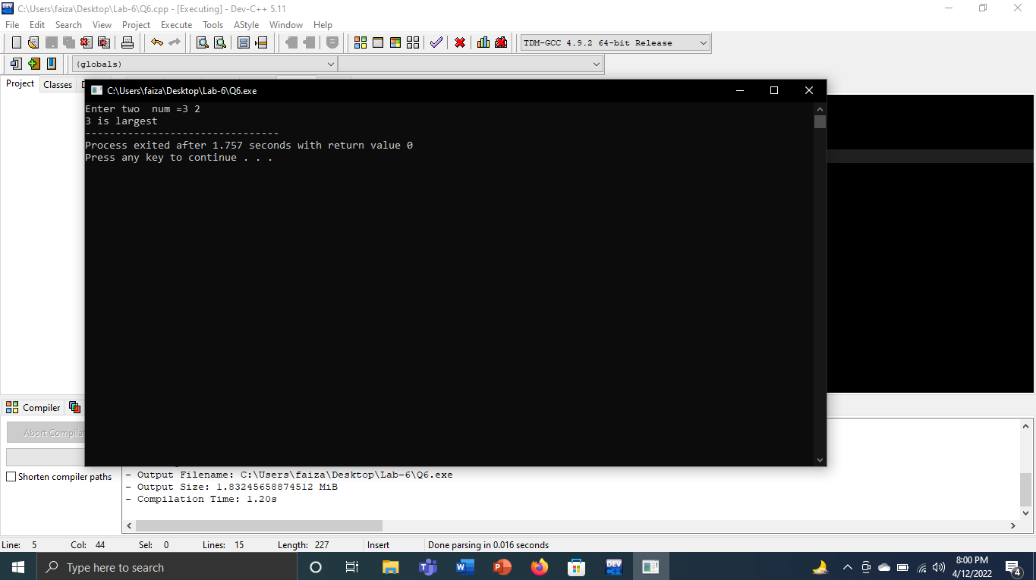

# Question No.7

## Input:

#include<iostream>

using namespace std;

int print(int i)

{

int n;

for(n;n<i;n++){

cout<<"#";

}

cout<<endl;

return i;

}

int main()

{

int num;

for(int c;c<6;c++){

while(true){

cout<<"Enter the num 1-20 =";

cin>>num;

if(num>=1&&num<=20)

{

break;

}

else{

cout<<"Wrong num"<<endl;

}

}

print(num);

}

return 0;

}

## Output:

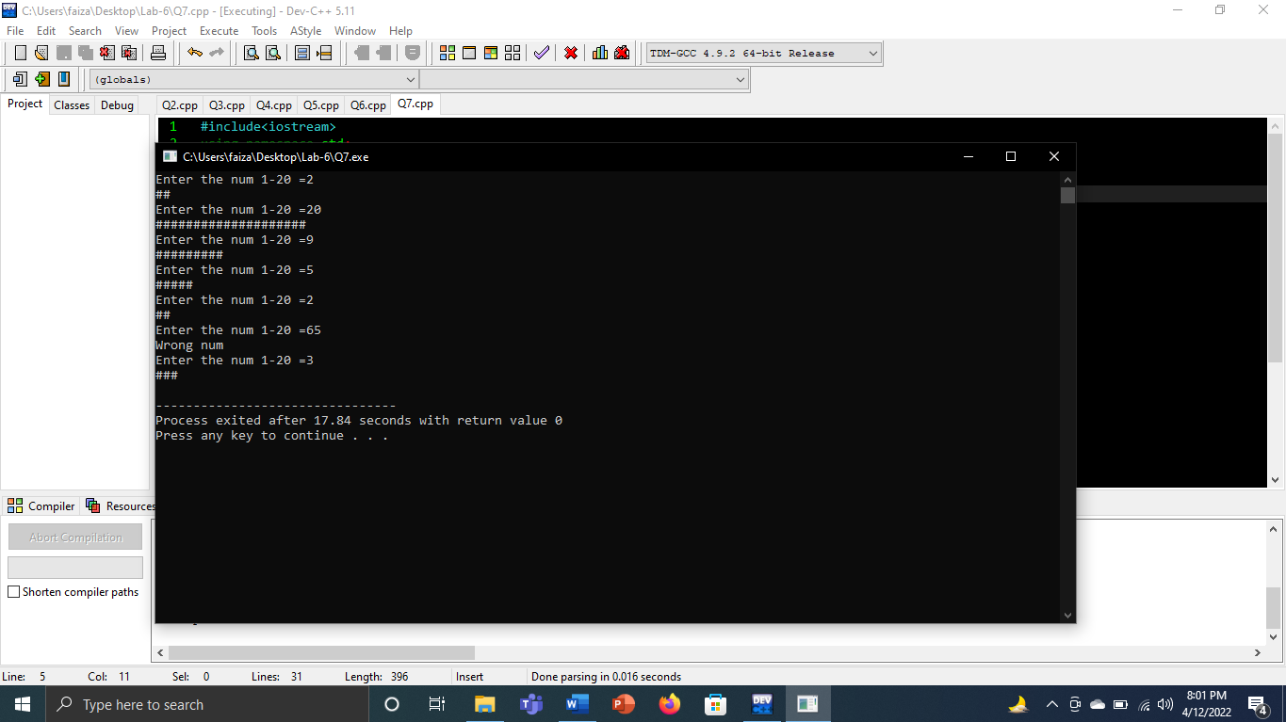

# Question No.8

## Input:

#include<iostream>

using namespace std;

float add(float n1,float n2,float n3,float n4,float n5){

return(n1+n2+n3+n4+n5);

}

float multi(float n1,float n2,float n3,float n4,float n5){

return(n1*n2*n3*n4*n5);

}

int main()

{

int num1,num2,num3,num4,num5;

char ans;

cout<<"Enter the num =";

cin>>num1>>num2>>num3>>num4>>num5;

cout<<"Enter operator =";

cin>>ans;

if(ans=='+'){

cout<<add(num1,num2,num3,num4,num5);}

else if(ans=='*'){

cout<<multi(num1,num2,num3,num4,num5);}

else{

cout<<"Enter invalid operator =";}

cout<<endl;

}

## Output:

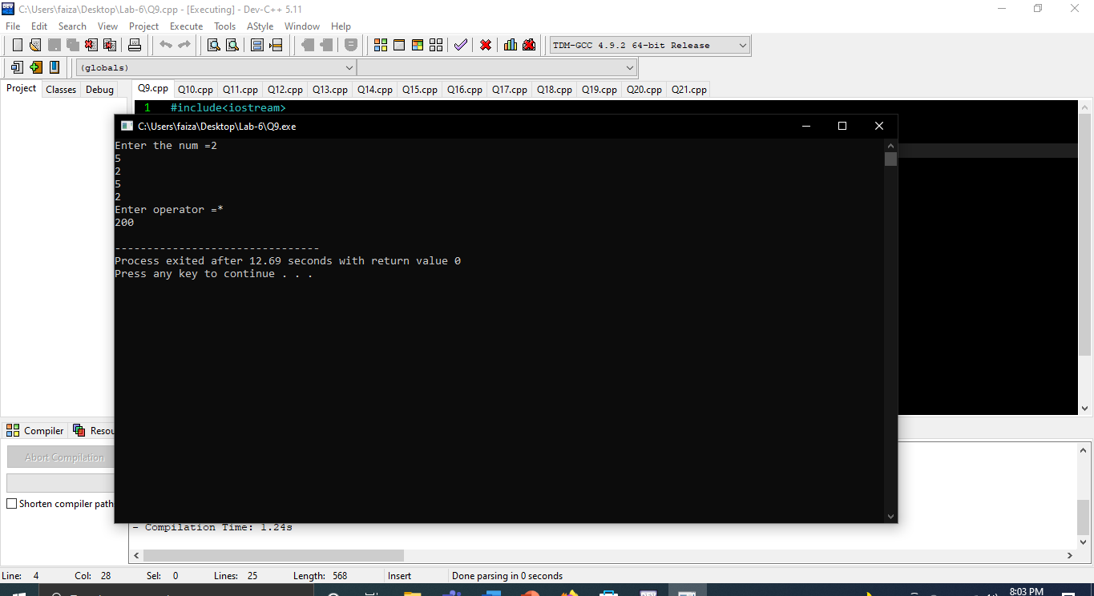

# Question No.9

## Input:

#include<iostream>

using namespace std;

float add(float n1,float n2,float n3,float n4,float n5){

return(n1+n2+n3+n4+n5);

}

float multi(float n1,float n2,float n3,float n4,float n5){

return(n1*n2*n3*n4*n5);

}

int main()

{

int num1,num2,num3,num4,num5;

char ans;

cout<<"Enter the num =";

cin>>num1>>num2>>num3>>num4>>num5;

cout<<"Enter operator =";

cin>>ans;

if(ans=='+'){

cout<<add(num1,num2,num3,num4,num5);}

else if(ans=='*'){

cout<<multi(num1,num2,num3,num4,num5);}

else{

cout<<"Enter invalid operator =";}

cout<<endl;

}

## Output:

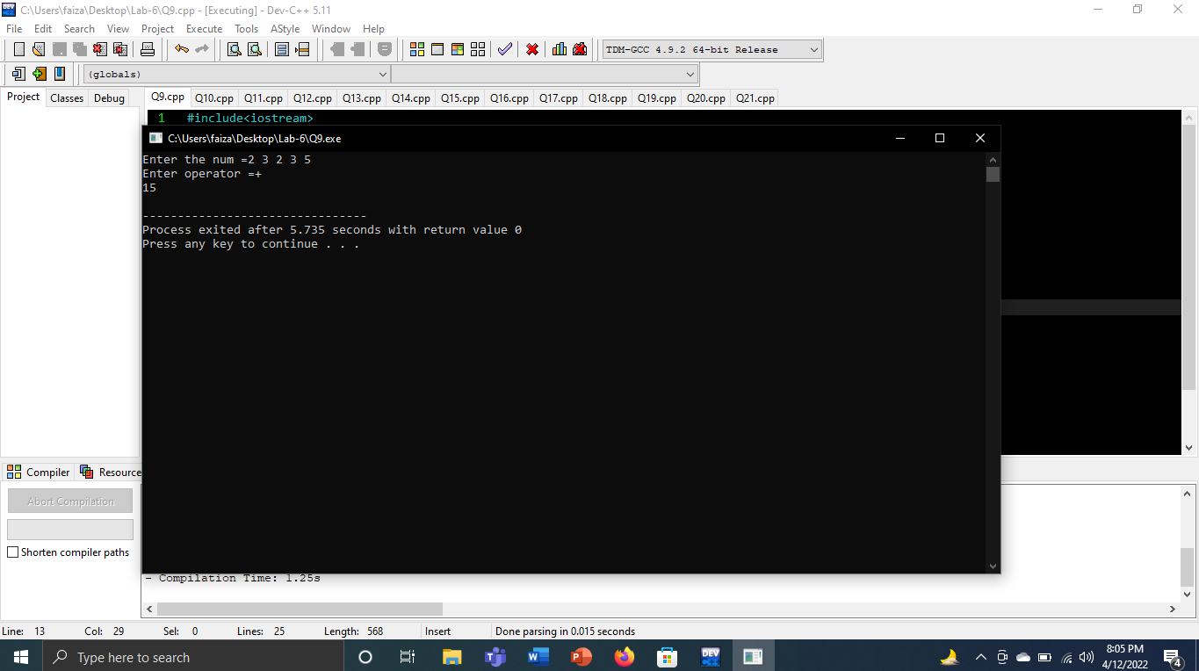

# Question No.10

## Input:

#include<iostream>

using namespace std;

float add(float n1,float n2,float n3,float n4,float n5){

return(n1+n2+n3+n4+n5);

}

int main()

{

float num1,num2,num3,num4,num5;

float add=0;

cout<<"Enter the five numbers =";

cin>>num1>>num2>>num3>>num4>>num5;

add=(num1+num2+num3+num4+num5)/5;

cout<<"Average is ="<<add<<endl;

return 0;

}

## Output:

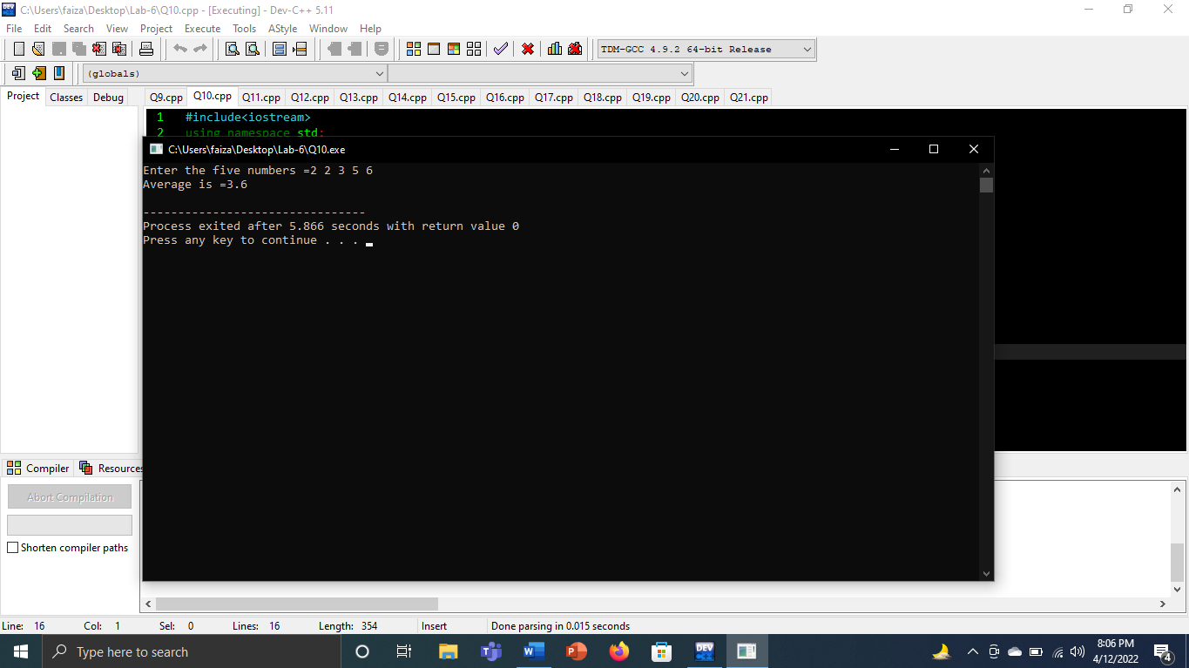

# Question No.11

## Input:

#include<iostream>

using namespace std;

float area( float n1)

{

const float pi=3.14;

return (pi*n1*n1);

}

int main()

{

float r;

cout<<"Enter radius =";

cin>>r;

cout<<"Area of circle ="<<area(r)<<endl;

system("pause");

return 0;

}

## Output:

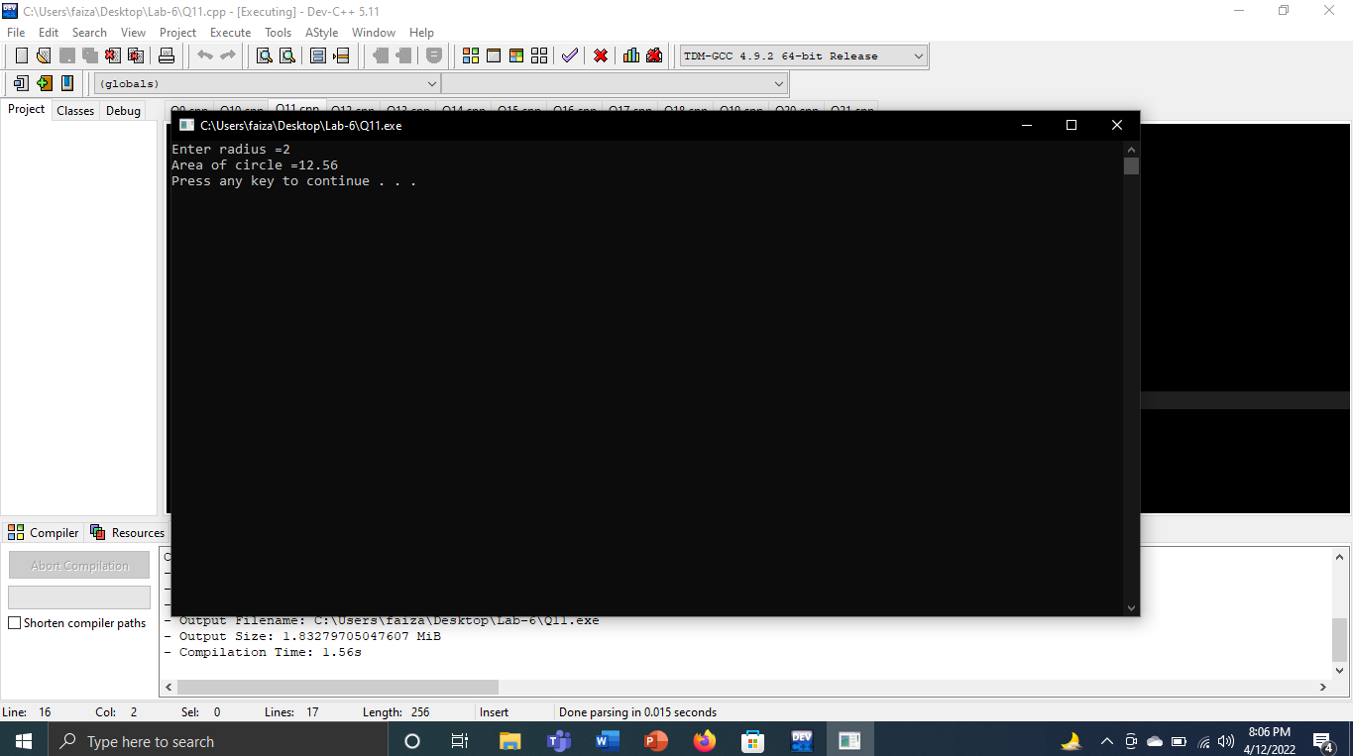

# Question No.12

## Input:

#include <iostream>

using namespace std;

float area(float radius,char s)

{

const float pi=3.14;

if(s=='a')

{

return(pi*radius*radius);

}

else if(s=='c')

{

return(2*pi*radius);

}

else

{

return 0;

}

}

int main()

{

float r;

char ans;

cout<<"Enter the radius(c=circumference,a=area) ";

cin>>r;

while(1)

{

cout<<"Enter the character: ";

cin>>ans;

if(ans=='a'||ans=='c')

{

break;

}

else

{

cout<<"Not character"<<endl;

}

}

cout<<"Answer is "<<area(r,ans)<<endl;

return 0;

}

## Output:

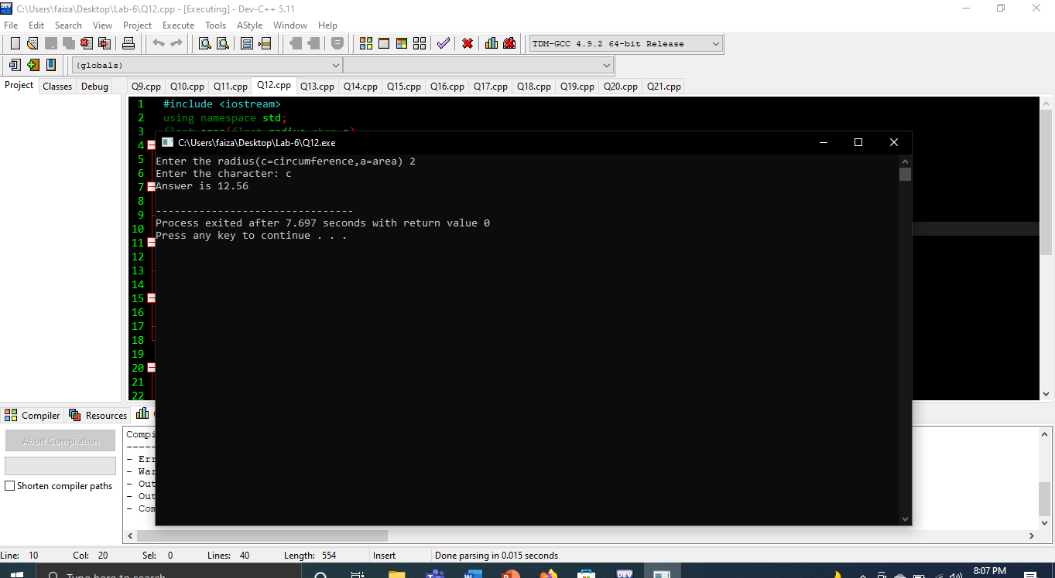

# Question No.13

## Input:

#include<iostream>

using namespace std;

int add(int arg1,int arg2){

return(arg1+arg2);

}

int sub(int arg1,int arg2)

{

return(arg1-arg2);

}

int multi(int arg1,int arg2)

{

return(arg1*arg2);

}

int div(int arg1,int arg2)

{

return(arg1/arg2);

}

int mod(int arg1,int arg2)

{

return (arg1%arg2);

}

int main()

{

int num1,num2;

char c;

cout<<"Enter the num =";

cin>>num1>>num2;

cout<<"Enter the operator(+,-,*,/,%) = ";

cin>>c;

if(c=='+')

{

cout<<add(num1,num2);

}

else if(c=='-')

{

cout<<sub(num1,num2);

}

else if(c=='*')

{

cout<<multi(num1,num2);

}

else if(c=='/')

{

cout<<div(num1,num2);

}

else if(c=='%')

{

cout<<mod(num1,num2);

}

else{

cout<<"Not operator "<<endl;

}

}

## Output:

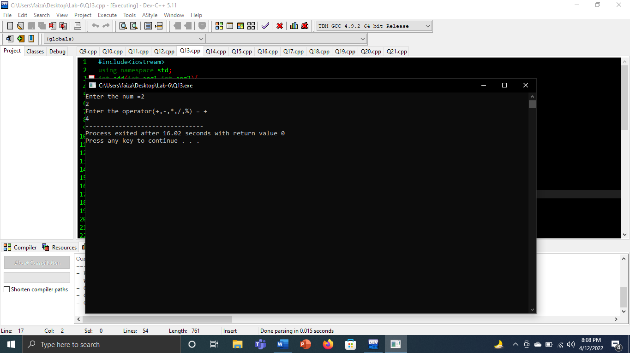

# Question No14:

## Input:

#include <iostream>

using namespace std;

void swap(int n1,int n2)

{

int temp;

temp=n1;

n1=n2;

n2=temp;

cout<<temp<<" swaps to "<<n1<<endl;

cout<<n1<<" swaps to "<<n2<<endl;

}

int main()

{

int num_1,num_2;

cout<<"Enter first number: ";

cin>>num_1;

cout<<"Enter second number: ";

cin>>num_2;

swap(num_1,num_2);

return 0;

}

## Output:

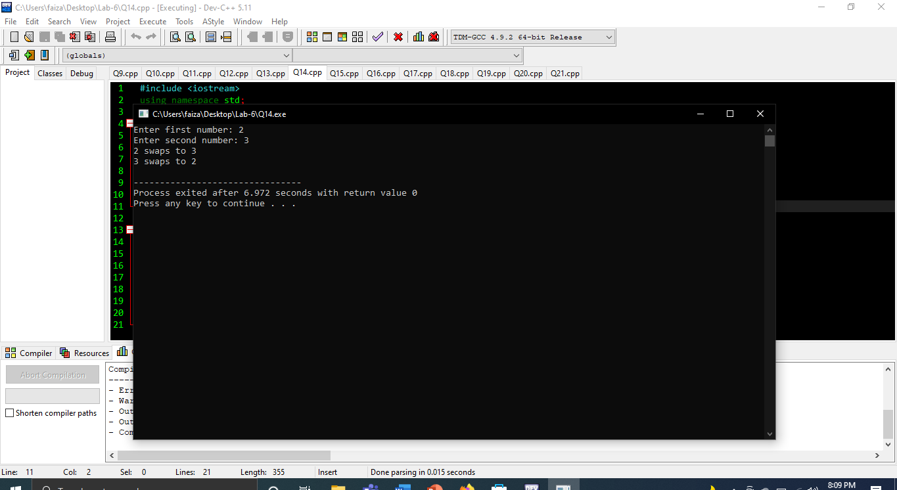

# Question No.15

## Input:

#include<iostream>

using namespace std;

bool check(int arg1,int arg2){

if(arg1%arg2==0)

{

return true;

}

else{

return false;

}

}

int main()

{

int x,y;

cout<<"Enter two number =";

cin>>x>>y;

cout<<check(x,y);

cout<<endl;

return 0;

}

## Output:

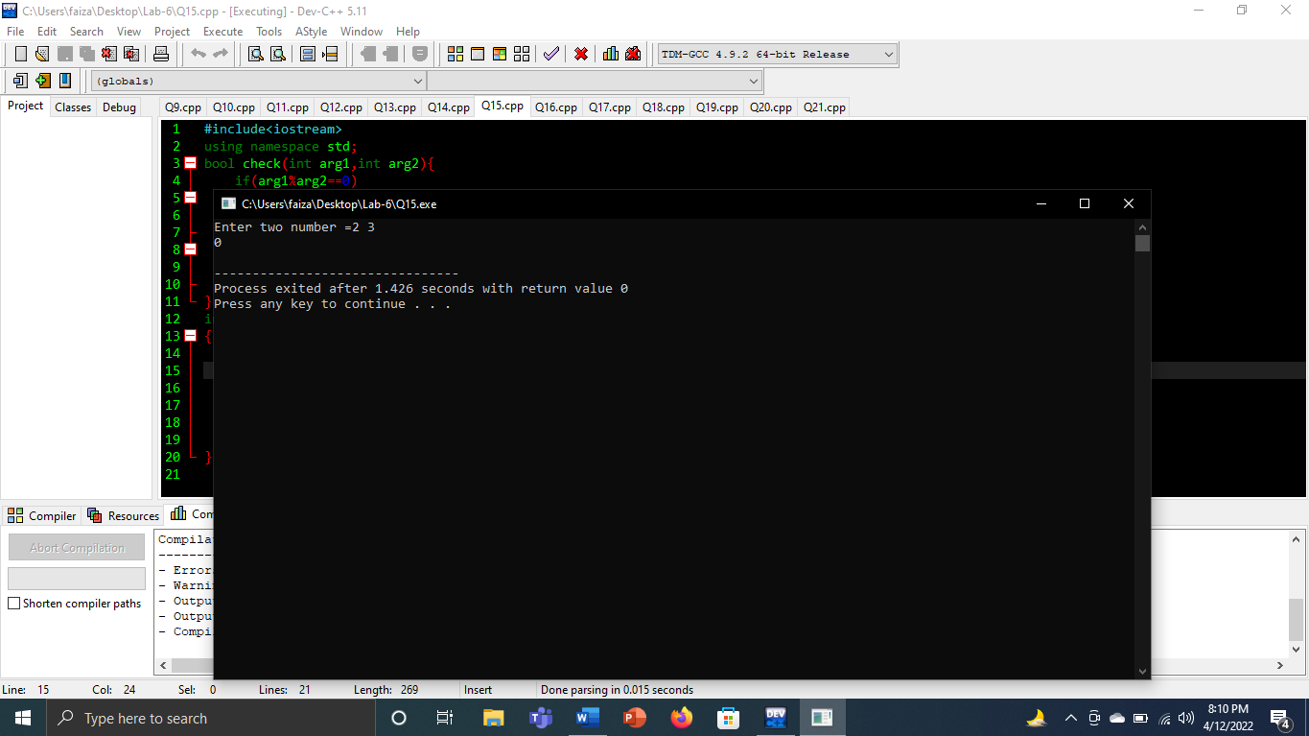

# Question No.16

## Input:

#include<iostream>

using namespace std;

int gcd(int n1,int n2)

{

int ans;

for(int c=1;c<=n1&&c<=n2;c++)

{

if(n1%c==0&&n2%c==0){

ans=c;

}

}

return ans;

}

int main()

{

int x,y;

cout<<"Enter two num =";

cin>>x>>y;

cout<<"Greatest common devisor =" <<gcd(x,y)<<endl;

return 0;

}

Output:

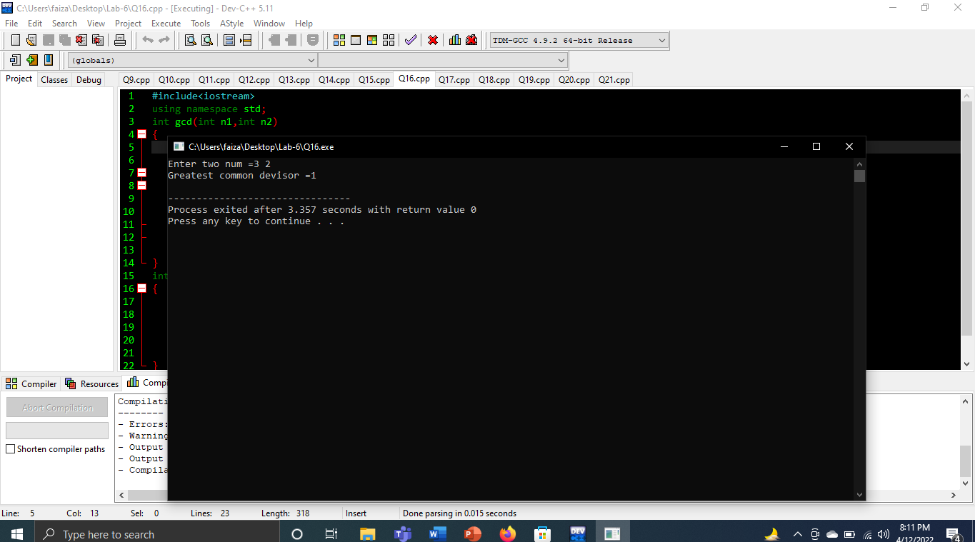

# Question No.17

## Input:

#include<iostream>

using namespace std;

int enc(int n)

{

int d1,d2,d3,d4;

d4=(n%10);

n=n/10;

d3=(n%10);

n=n/10;

d2=(n%10);

n=n/10;

d1=(n%10);

n=n/10;

d1=(d1+3)%10;

d2=(d2+3)%10;

d3=(d3+3)%10;

d4=(d4+3)%10;

return((d1*1000)+(d2*100)+(d3*10)+d4);

}

int dec(int n){

int d1,d2,d3,d4;

d4=(n%10);

n=n/10;

d3=(n%10);

n=n/10;

d2=(n%10);

n=n/10;

d1=(n%10);

n=n/10;

d1=(d1-3)%10;

d2=(d2-3)%10;

d3=(d3-3)%10;

d4=(d4-3)%10;

return((d1*1000)+(d2*100)+(d3*10)+d4);

}

int main(){

int num;

char ans;

cout<<"Enter num =";

cin>>num;

while(1){

cout<<"Enter the (encrypt and decrypt) =";

cin>>ans;

if(ans=='e'||ans=='d')

{

break;

}

else{

cout<<"Enter 'e' or 'd'"<<endl;

}

}

if(ans=='e')

{

cout<<"Now number is = "<<enc(num)<<endl;

}

else

{

cout<<"Now number is = "<<dec(num)<<endl;

}

system("pause");

return 0;

}

## Output:

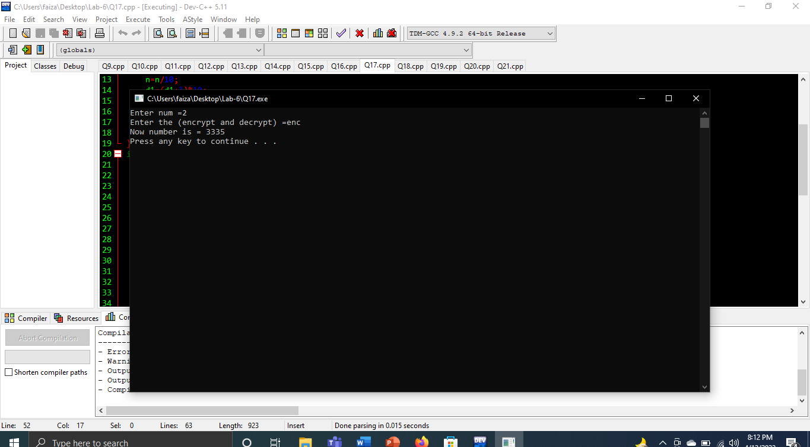

# Question No.18

## Input:

#include<iostream>

using namespace std;

int main()

{

int num;

int&ref1=num;

float num2;

float&ref2=num2;

char num3;

char&ref3=num3;

cout<<"Enter the integer =";

cin>>ref1;

cout<<"Enter the float =";

cin>>ref2;

cout<<"Enter the character =";

cin>>ref3;

cout<<num<<endl;

cout<<num2<<endl;

cout<<num3<<endl;

return 0;

}

## Output:

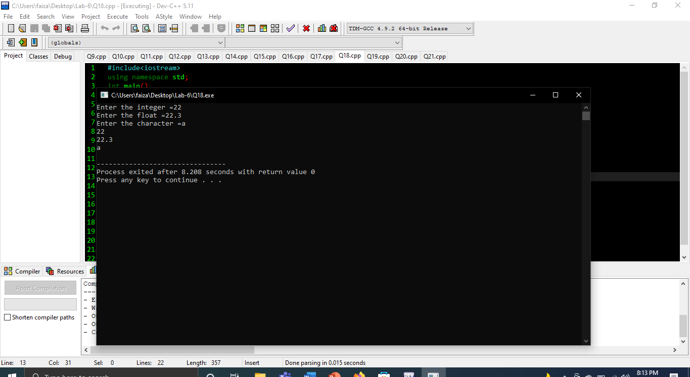

# Question No.19

## Input:

#include<iostream>

using namespace std;

int main(){

char x,y;

char&ref1=x;

char&ref2=y;

cout<<"Enter one character =";

cin>>x;

cout<<"Enter another character =";

cin>>y;

cout<<ref1<<endl;

cout<<ref2<<endl;

return 0;

}

## Output:

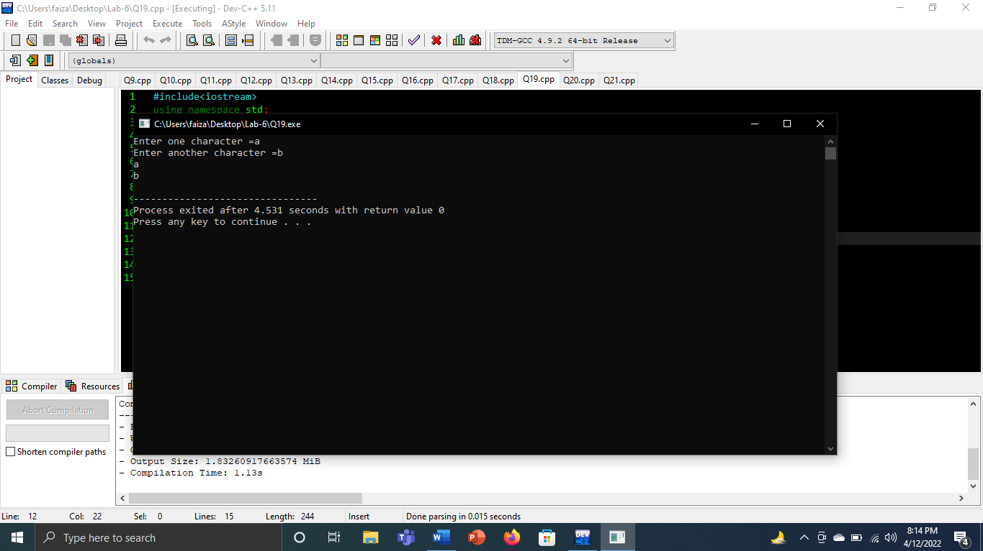

# Question No.20

Input:  
#include<iostream>

using namespace std;

void swap(int x,int y)

{

int temp;

temp=x;x=y;

y=temp;

cout<<temp<<" has become "<<x<<endl;

cout<<x<<" has become "<<y<<endl;

}

int main(){

int num1,num2;

int &ref1=num1,&ref2=num2;

cout<<"Enter the number =";

cin>>num1>>num2;

swap(ref1,ref2);

cout<<endl;

return 0;

}

## Output:

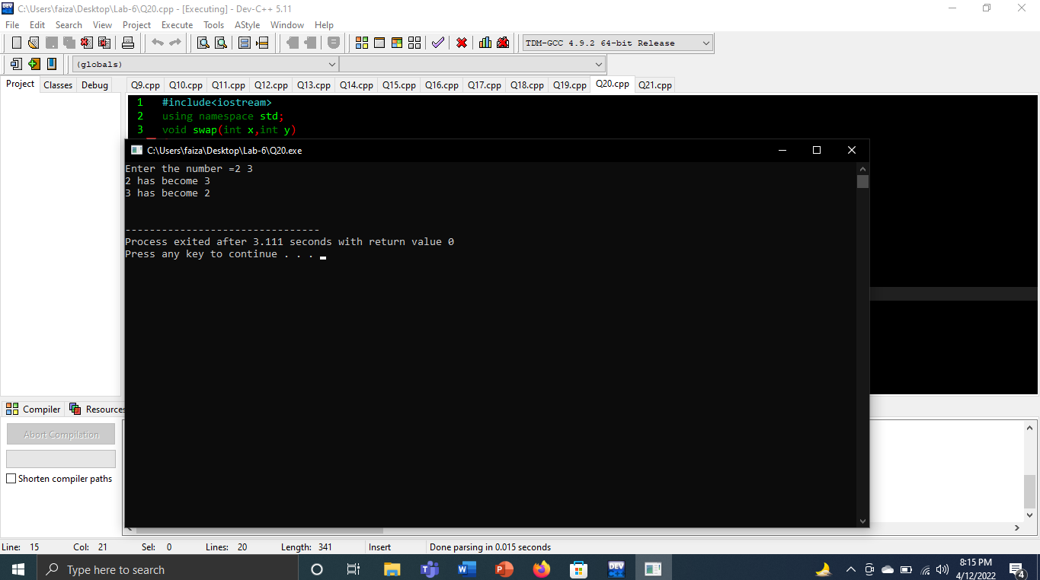

# Question No.21

## Input:

#include<iostream>

using namespace std;

void value(int a1,int b2,int c3,int d4,int e5){

}

int main()

{

int a=0,b=0,c=0,d=0,e=0;

cout<<"Enter the five numbers =";

cin>>a>>b>>c>>d>>e;

value(a,b,c,d,e);

int&ref1=a,&ref2=b,&ref3=c,&ref4=d,&ref5=e;

cout<<ref1<<endl<<ref2<<endl<<ref3<<endl<<ref4<<endl<<ref5<<endl;

return 0;

}

## Output:

